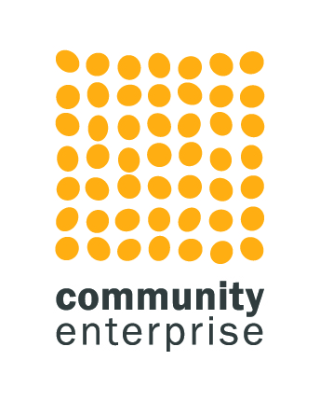

Caraidean Uibhist (SCIO)
Impact Report

February 2023

Contents

Executive Summary 3
1: Introduction and Background 5
1.1 Introduction 5
1.2 Services 6
1.3 An Essential Service 7
1.4 Common Thread 8
1.5 Succes and Achievements 8
1.6 Research Aims 9
1.7 Methodology 9
2: Current Landscape 11
2.1 Statistics 11
2.2 Benefits of Befriending – The Data …………………………12
3: Findings - Key Features and Themes 15
3.1 What they Do Well………………………………………..…………15
3.2 Impact 16
3.3 Perception 19
3.4 Gaps and Opportunities 21
3.5 Spotlight activity 22
4. Challenges 23
4.1 Internal 23
4.2 External 24
5. Conclusion 25
5.1 Conclusion 25

Executive Summary

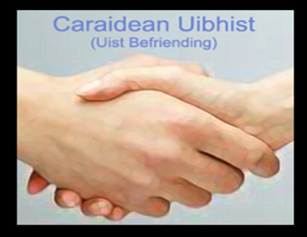
The Impact Report which gathered feedback from service users, staff, volunteers, trustees, partners, and referral agencies explores the impact that the services of Caraidean Uibhist is having across the five island communities that it serves and identifies where it can strengthen its provision and ensure that it meets current as well as future need and demand.
There was overwhelming support for the work of Caridean Uibhist and its operating model with the organisation being recognised for its value-based approach and for placing the service user at the heart of its activity. Feedback identified a high-quality service that was tailored to the needs of the individual as well as their wider community, and a team of staff and volunteers that were committed and caring.
Emerging themes included:
- Essential service
- Tailored and bespoke provision
- Placing the service user at the heart of all activities
- Passionate and caring staff and volunteers
- Creating opportunities for people
- Community focussed
- Providing a personalised and tailored service
- Fast response to changing needs
- Friendly and fun

The organisational impact was far reaching, going beyond the original parameters of reducing social isolation and loneliness, as is their service provision which includes alcohol and substance use support, and an off-island appointment escort service.
I would be totally isolated without them
(service User)

Some of the key impacts that emerged from the feedback helped identify the wide-reaching nature of the services provided, including:

- Connectedness with friends and the community
- Positive mental health and wellbeing
- Improved cognitive ability
- Improved physical fitness and physical wellbeing
- Helping people apply for and get grants and support
- Helping people learn new skills
- Encouraging independence
All respondents agreed that the staff and volunteers provide a high-quality personalised service which continued through the exceptional pressures placed on the service and the five island communities during Covid-19. There was also recognition that the current need and demand for their services would very likely increase as the longer-term impact of Covid-19 becomes more evident.

Like many organisations in the voluntary sector there are a number of challenges facing the organisation, some internal and others external. The most notable challenge is to secure long term sustainable funding while continuing to meet the increasing need and demand for their services; in an environment where the value of funding available is reducing while the expected deliverables are increasing. This being coupled with the need to often demonstrate immediate and long-term efficiencies.
As an organisation it should continue to create, nurture, and develop partnerships and collaborative working across the five island communities it supports, and beyond. It was important for partners and external stakeholders that Caridean Uibhist did not work in isolation or duplicate services and continued to be complementary to other provision.
It’s the reliability of our services that gives people faith
(Trustee)

1: Introduction and Background
1.1 Introduction
Caraidean Uibhist was originally established in March 2003 to provide a befriending service to socially isolated adults living in five island communities in the Outer Hebrides. The aim of the project is to reduce loneliness and social isolation and help build confidence and self-esteem amongst people facing difficulties in their life, particularly in rural areas within the Uist community (Eriskay, South Uist, Benbecula, North Uist and Berneray).

The service is designed to improve users' quality of life through:

- Increased independence and improved self-esteem
- Access to mainstream activities
- Improved social well-being and physical and psychological health
- Reduced social isolation and exclusion

With only 26,370 inhabitants and an average of 9 people per square kilometre the Outer Hebrides are one of the least populated areas in Scotland. The populated islands of the Outer Hebrides and number of inhabitants vary:

- Lewis and Harris 20,000
- South Uist 1,800
- North Uist 1,300
- Benbecula 1,200
- Barra 1,100
- Berneray 140
- Scalpay 320
- Great Bernera 230
- Grimsay 200
- Eriskay 130
- Vatersay 100
- Baleshare 50

The population serviced by Caraidean Uibhist covers five islands and comprises of approximately 5,000 people.

Since its formation the organisation has grown and extended its reach to ensure that all those in the community can access their services no matter their location, Indeed, the organisation currently supports service users from all five island communities. While historically the main service provided has been befriending, they also provide a range of tailored and specialised wrap around support including substance misuse support, mental health support, named contacts (through staff and volunteers) as emergency response for individuals living alone, and arranging volunteers to escort patients for both local and off island appointments.

Caraidean Uibhist, like many organisations were not alone in having to adapt and evolve to a changing landscape brought about by Covid-19, and as an organisation they continued to support service users from all five island communities through operationally challenging conditions. In addition, they continued to align their activity to the six core objectives:

- Increased well-being
- alleviating depression triggers
- combatting loneliness
- improving quality of life
- increasing self-esteem
- changing social attitudes

we do well when considering the logistical hurdles, we are very spread out, maybe a 50-mile radius (Staff Member)
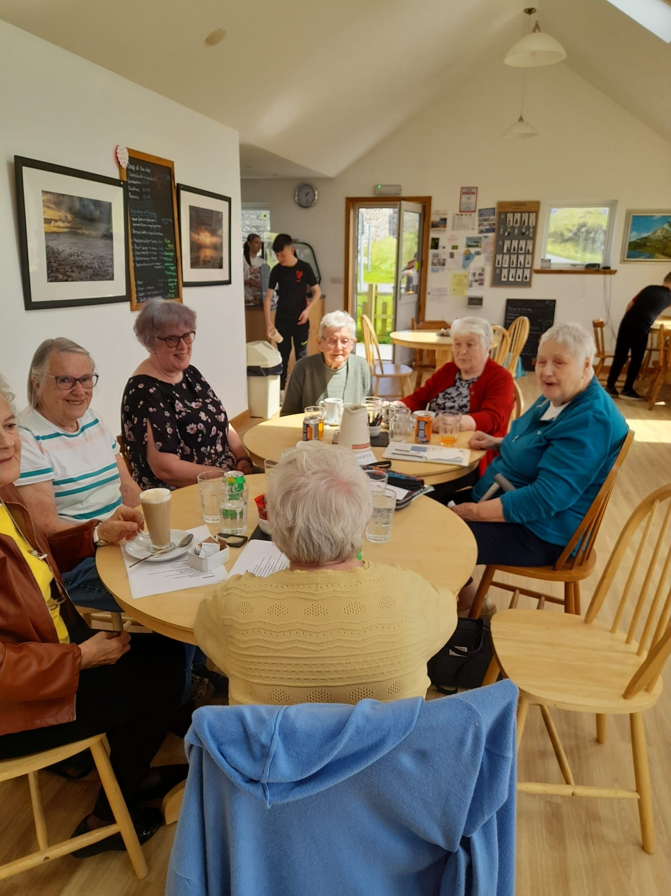
As evidence suggests the increasing needs of those most vulnerable in our communities became more prevalent during Covid-19, as not only was the traditional infrastructure designed to support those in greatest need impacted, but also the wider public health services and local and national economy.
For Caraidean Uibhist, the communities they support were further impacted by the often rural and isolated nature of their locations and the often-challenging logistics, further impacting on individuals social isolation and loneliness. It was evident that during Covid-19 the organisation continued to create connections, building confidence, support people to live as independent as possible, and reduce social isolation and loneliness.
1.2 Services
Befriending
The Befriending service, which support anyone aged over 18, is a key strand of Caraidean Uibhist activity which has seen an increase in both need and demand since Covid-19. There are a number of components to the Befriending service, some introduced in response to Covid-19 including telephone-based contact, digital platforms such as ZOOM or Teams, in person one-one contact and group activity.
They are always encouraging towards me, and I feel welcomed
(Service User)

The flexible nature of the delivery model delivered by a team of highly skilled and experienced staff and volunteers help ensure that a befriender and befriendee match is arranged quickly and efficiently, in order to meet an emerging or ever-changing need and demand.

Alcohol and Drug Support
In collaboration with the Outer Hebrides Alcohol and Drug Partnership (OHADP), Caraidean Uibhist provide a high quality, person centred, service for all those in the local community who are socially isolated and affected by problematic use of alcohol or drugs. The specialist service is tailored to the needs of the individual and also engages the key stakeholders including carers and family members. Given the nature of the service and needs of the client group Caraidean Uibhist were proactive in ensuring that there was a continued service during the early stage of Covid-19; securing funding for mobiles and tablets enabling those in greatest need to engage online via digital platforms, as well as allowing for a rise in the volume of clients engaging the service.
It’s good for my mental health
(Service User)

Caraidean Uibhist facilitates a range of one to and group activities, helping create, foster, and develop social links with the wider community, and ensure cognitive stimulation. They provide opportunities to improve service users health, wellbeing, social skills, confidence levels, independence, and resilience by promoting social inclusion and community cohesion through creative activities. The activities are wide ranging and include:

- Visits and meet ups
- One-one support
- Personalised time
- Group activity
- Social events
- Sit and Yarn
- Off island escort service

1.3 An Essential Service
The prevalence of social isolation, loneliness, poor mental health, and wellbeing has increased within many communities in Scotland since Covid-19. Not only has Covid-19 impacted on the traditional welfare, health and social infrastructure designed to support those in greatest need but also affected the wider economy. The need for providing basic health and wellbeing support has increased dramatically, as has the risk of poor mental health, social isolation, debt, relationship pressures and unemployment. When placed in the context of rural island communities this results in even more pressures being placed on services.
The negative effects of loneliness and isolation are increasingly recognised in society, particularly since the Covid-19 pandemic. Research shows the success of befriending programmes such as that provided by Caridean Uibhist in alleviating loneliness and isolation as well as increasing confidence, connectivity, and wellbeing among participants especially when a meaningful, mutually trusting relationship is developed.
Creating, forming, and sustaining relationships are central to a person’s well-being and are crucial to maintaining good physical health, mental health, and a holistic sense of meaning and purpose. Feedback from Caridean Uibhist service users helps to illustrate the high quality and bespoke provision they receive, much of which continued seamlessly through challenging circumstances as a result of Covid-19.
I get to see people and have fun with them
(Service User)

As for many organisations it was a challenge to operate during Covid-19, not only due to the traditional close contact and personal support provided but the need to introduce new ways of working which required investments in digital infrastructure and equipment; and ensuring that staff, volunteers and service users health and welfare were maintained. Further, the staff and volunteers played a critical role in encouraging and supporting service users to resume social activity and to re-engage with their community and social networks when restrictions allowed.
Beyond the benefits to the befriendee, the Caraidean Uibhist model also impacts positively on the befrienders, as was seen during Covid-19 when there was a shared lived experience and having that social interaction was a two-way process, particularly when seen through the lens of a rural island environment.

1.4 Common Thread
There are many features of both the Befriending Service and Drug and Alcohol Support that ensure they both align to the core values and objectives of the organisation, all of which was evident in the stakeholder feedback:
- Person centred
- Community driven
- Tailored
- Caring
- Essential
- Positive benefits to health and wellbeing
1.5 Caraidean Uibhist - Success and Achievements
Caraidean Uibhist have not been alone in having to adapt to a changing landscape and exceptional circumstances brought on by Covid-19. The increasing need and demand for support to help the most vulnerable, many argued was unprecedented, coupled with the stretch and challenge placed on the traditional infrastructure designed to support those in greatest need, and the negative impact on the local and national economy.
The impact is measured in a wide range of ways…. social inclusion, metal health and well-being, respite for families, keeping people active
(Strategic Partner)

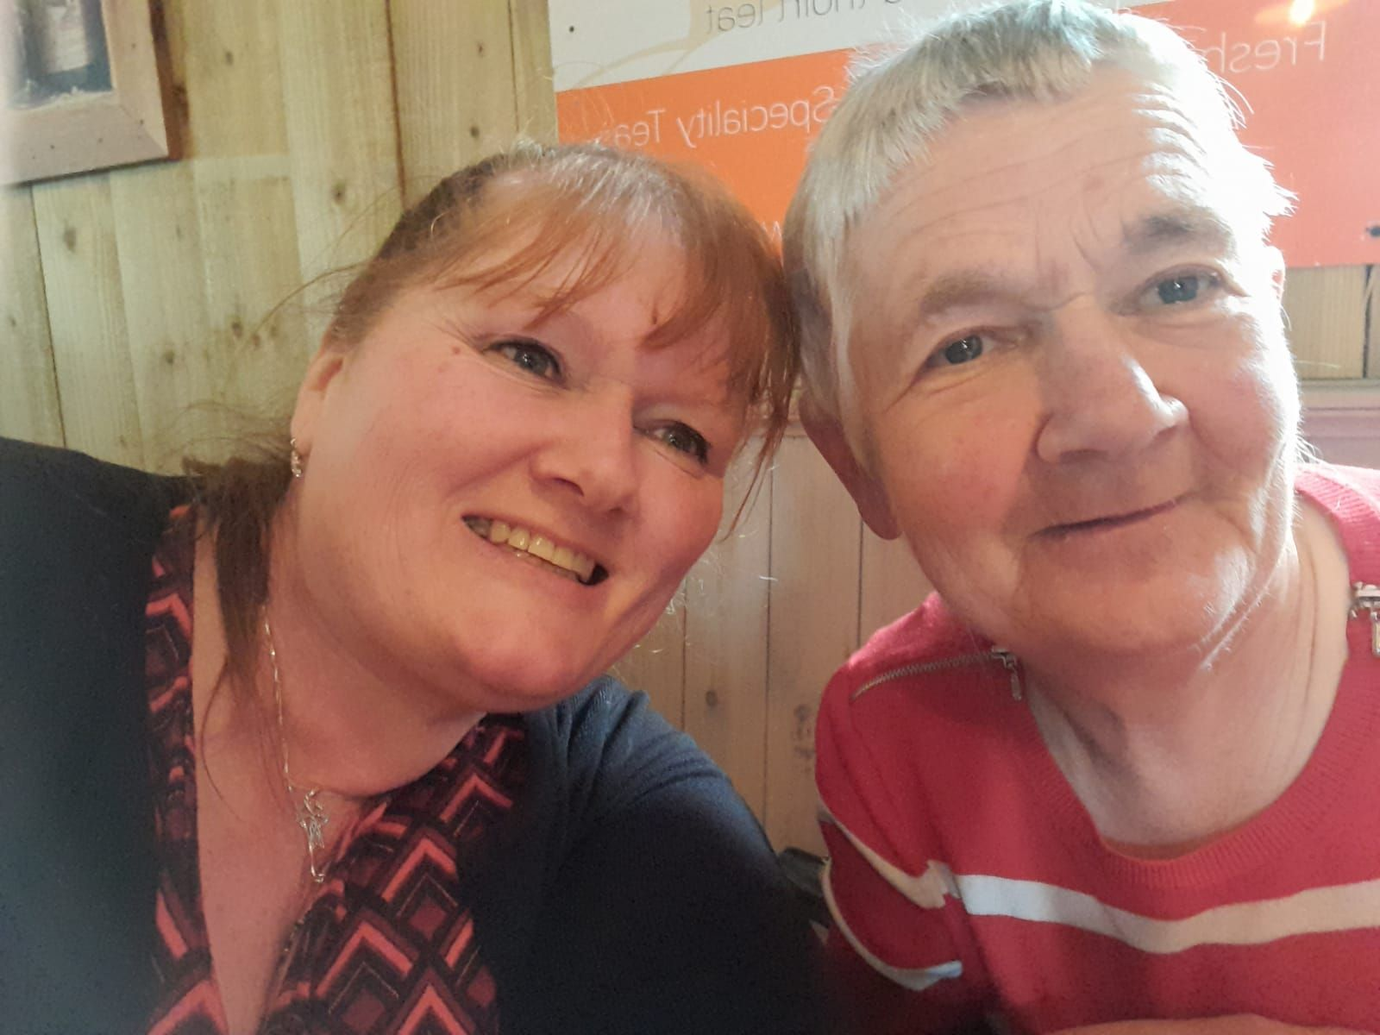
While there are some clear and defined outcomes, such as reduced loneliness and increased connectivity there are a number of additional and sometimes unintended outcomes such as the person re-engaging with a hobby such as music or connecting with families. Further, as feedback suggested, there is a positive impact on the befriender who benefits from increased social interaction and to discover parts of their island community they may not have otherwise visited or known about.
For the organisation to continue to provide services during Covid-19, whether that was remote or on-line, was a major achievement and testament to the organisation’s ability to be flexible, agile, responsive, and proactive.

The organisation had a number of successes and achievements during 2021/2022 including:
- Provide bespoke services across all 5 island communities
- Extending provision into Dementia services support
- Achieved The Volunteer Friendly Award status
- 75 people successfully matched with a befriender
- 28 supported through the Alcohol and Drug Prevention
- 10 people supported to access appointments through the Off-Island Escort Service
- Provided 4,680 volunteer hours to the community
- Created partnerships with Food Bank to deliver food parcels
- 60 individuals attended on-line events
- Distribute a Newsletter across all five island communities
- Established Gaelic Medium Intergenerational activity
If it wasn’t for us the only person, they might see is the postman
(Volunteer)
1.6 Research Aims
Community Enterprise was commissioned by Caraidean Uibhist to undertake an external impact exercise to help identify and understand the difference its work is making across the five island communities.
This research focused on the following areas:
- Understanding the experience of those connected to the organisation including service users, families, referral agencies, staff, volunteers, and trustees
- Exploring the impact, the organisation is having on the lives of service users
- Identifying what stakeholders think is working well, where there are areas for improvement, or where there are gaps in the existing services

1.7 Methodology
As part of the exercise a qualitative information gathering exercise was undertaken which included one to one discussion with service users, family members, carers, referral agencies, funders, staff, volunteers, and trustees. To gather as much qualitative feedback as possible, existing service user feedback was also used. Those participating had options for a one-one discussion or to complete a questionnaire, the majority preferred to engage in a discussion.
Each participant was asked a series of set questions, with opportunities for those who wanted to consider the questions further or would prefer to respond in confidence, to send their responses by email. The exercise was underpinned by a qualitative research approach that aimed to explore key perspectives and experiences from a range of stakeholders.

Respondents:
- Service Users - 9
- External Stakeholders - 6
- Staff, Volunteers, Trustees – 20

We are immensely proud to receive this recognition and reflects the dedicated and long hours the Caraidean team put in to ensure that the organisation provides the service that it does to our community; without our Volunteers, we would not exist …. they are such an integral part of the Caraidean family, from befrienders to volunteer support workers, to the Board themselves, without them we would not be able to continue to flourish
(Manager on being awarded the Volunteer Friendly Award)

2: Current Landscape
2.1 Statistics
In Scotland, in 2020, 35% of adults felt lonely, some, most, almost all, or all of the time (in the previous 7 days), according to the Scottish Household Survey. This is compared with 21% in 2018. and clearly illustrates the need for ‘A Connected Scotland’, which is the Scottish Government’s national strategy for tackling social isolation and loneliness.
Further research suggests that befriending helps to alleviate loneliness and social isolation through meaningful and reciprocal friendship-like support and opportunities to engage in community and social activities. This impact is especially notable among groups of people who are at higher risk of isolation, including older adults, those with mental health problems or long-term health conditions, mothers with young children, carers, and minority ethnic groups.
While those most vulnerable in our communities may not necessarily need a befriending service or experience loneliness or social isolation, indeed feedback from Caraidean Uibhist has suggested that there are younger people and younger mums who would benefit, it is recognised that there is likely to be a higher risk of isolation and loneliness. In addition, the increased pressures placed on paid and unpaid carers during Covid-19, and that placed on traditional health service provision, has negatively impacted on the ability to provide primary health care and the pastoral support, increasing the potential for social isolation and loneliness.
Currently in the UK there are 1 in 5 adults (10.58 million people) providing care to a relative, close friend or neighbour. Since Covid-19, the number of carers providing 20+ hours per week of unpaid care has jumped by over 42%.
In Scotland, there are an estimated 1.1 million unpaid adult carers, which represents a steep rise from the 729,000 prior to Covid-19. It is estimated that nearly 400,000 adults took on caring for the first time, with rates remaining higher than before Covid-19 .
Carers UK estimates there were 270,000 carers juggling work and unpaid care in Scotland pre-pandemic. This soared by a further 227,000 during Covid 19 with nearly three-quarters saying that they were concerned about not being able to continue to manage both the care and work responsibilities.
Of those currently caring, 22% care for between 10-19 hours per week, 14% for between 20-49 hours per week and 14% over 50 hours per week. In Scotland (as well as across the UK), the volume, scale and intensity of care has grown since Covid-19 chiefly because of health and support services remaining closed or restricted, acute pressure on primary health care and the continuing shortage of social care staff.

2.2 Benefits of Befriending - The Data
The staff, volunteers, and trustees of Caraidean Uibhist recognise that reaching out to those most at risk through their tailored befriending service helps improve the mental health and wellbeing of the five island communities they support and helps reduce the risk of social isolation and loneliness. They also believe that befriending has the unique ability to operate across all levels of prevention, which also has a positive effect on costs associated with any statutory provision.
Caridean Uibhist also believe that befriending can be used to support people with low to moderate health and social care needs; helping prevent people from entering into the health system and requiring social care for the first time. While befriending can help prevent further deterioration of an existing condition and the need for extra care it can also be used to support people with high complex needs to help reduce long-term dependency upon acute service provision such as residential care.
The negative effects of loneliness and isolation, among all generations is becoming more recognised as we start to see the longer-term impact of Covid-19, most notably the negative impact on mental health and wellbeing.
It’s the reassurance that we will phone them or contact them that is so important …. It’s comforting to people that we are there to talk to
(Staff Member)

According to Age Scotland, approximately 200,000 older people in Scotland will go half a week without a visit or call from anyone, and loneliness is said to be as dangerous to one’s health as smoking 15 cigarettes a day! Findings in A Stitch in Time: The Benefits of Befriending study for Befriending Network; a study exploring perceptions of change in mental well-being among older service users who have received befriending, identified that there is a paucity of good evidence demonstrating the benefit of befriending services.
In addition, research has shown the success of befriending programs in alleviating loneliness and isolation and increasing confidence, connectivity, and wellbeing among befriendees especially when a meaningful, mutually trusting relationship is developed.
Loneliness, according to the Campaign to End Loneliness, is one of the largest health concerns we face, suggesting that:
- Loneliness is likely to increase your risk of death by 26%
- Loneliness is worse for you than obesity
- Loneliness and social isolation are associated with an increased risk of developing coronary heart disease and stroke
- Loneliness increases the risk of high blood pressure
- Loneliness with severe depression is associated with early mortality and loneliness is a risk factor for depression in later life
- Loneliness and social isolation put individuals at greater risk of cognitive decline and dementia
New analyses of ONS data from the Campaign to End Loneliness found that between December 2021 and February 2022:
- 3.3 million people living in Britain were chronically lonely (or felt lonely all the time) between December 2021 and February 2022
- This compares with a previous survey from April and May 2020 which indicated that 2.6 million adults were chronically lonely
- Around 1 million younger people (aged 16-29) were chronically lonely
British Red Cross identified that their community befriending service helped improve the wellbeing of its service-users; positively impacted on the health and wellbeing of the volunteers; as well as helped reduce the cost to the NHS through a reduction in missed health care appointments. The findings also suggested for every £1 invested in the service there was a social return on investment of £1.48. Studies such as the that undertaken by Deloitte, which used UK Cabinet Office guidelines, suggested that for every £1 invested by Befriend a Child (in their befriending service) there was a social return outcome of £6.13 .
Walsall Council when conducting an evaluation of their befriending as part of the Social Prescribing Services identified 5 key outcomes:
- Improved sociability: connecting with people and making friends; laughter; engaging; and fun
- Improved mental health: from feeling anxious or depressed to feeling normal or a boost to feeling more positive; comfortable; relaxed; and safe
- Keeping occupied: filling time and not being bored
- Improved physical health: feeling better physically; better physical health; better sleep; eating properly; mentally active
- Given a purpose: having a role to play and helping others

Of interest was the unexpected positive impact of befriending on both the befriender and the befriendee, as well as the wider impact, which was also identified in Caraidean Uibhist feedback. Key unexpected outcomes included improvements to people’s homes following the Fire Service’s Safe and Well visits, clients becoming volunteers and then staffing the befriending service; offering new activities for the local community; and centres becoming more older people friendly.
Our befriending services offer a valuable intervention which can reduce, or prevent, loneliness and/or social isolation, especially in older people is how Bradford VCS Alliance services were described in the 2019 study on harnessing the power of communities across Bradford. The findings seemed to echo feedback from the Caraidean Uibhist stakeholders including:
- Loneliness and social isolation represented a very significant threat to health and are important risk factors for a wide range of mental and physical health problems including depression, high blood pressure, sleep problems, reduced immunity, and cognition in older people

- Older people who are lonely and/or isolated have substantially increased chances of developing dementia and Alzheimer’s disease. For such older people, loneliness is also associated with high blood pressure, an increased number of GP visits and higher incidences of falls.
- Addressing the causes of loneliness and social isolation improves the quality of life for individuals but is also likely to lead to reduced costs by delaying, or reducing, the need to access health and social care services.
- The benefits for befriendees of receiving support through befriending schemes are significant and include: a reduction in isolation; an increased feeling of being part of the community; increased independence; an increased ability to socialise and improved physical and mental health.
- The benefits for those undertaking the befriending include increased understanding of the issues facing older and/or isolated people, increased skills and knowledge and increased friendships and social networks.
- There are a range of benefits for others involved such as the families and carers of those being befriended and the statutory agencies who would experience increased workload and costs if the schemes were not in operation.

It was also suggested that there was a return of almost 15:1 for each pound spent on the befriending services which equated to an average impact value of around £3,900 per person for a cost of just £260 per year.

3: Findings - Key Features and Themes
3.1 What they do Well
All respondents were positive towards the work carried out by Caraidean Uibhist and could clearly evidence the impact it was making in the lives of people experiencing social isolation and loneliness across all five island communities, while also recognising the complementary nature of their service to other third sector and statutory provision.
It’s a form of Freedom
(service user)

It was evident in the feedback that the staff and volunteers put the person at the centre of their activities and adopt a person-centred approach, providing a service that is individually tailored to the needs of the service user. Indeed, the person-centred and bespoke nature of the service were a common feature in the responses. There were a number of key themes identified including:
Service Users:

- Instils fun into activities
- Facilitates and creates opportunities for friendships to develop
- Listen to people
- Support people to get to events and local amenities
- Improves connectivity between people and communities
- Helps people get active and mobile
- Helps take pressure off friends and family

External Partners:

- Contributes and complements wider services and provision
- Actively collaborate with other partners and stakeholders
- Provides opportunities for both tailored one-one support and group activities
- Helps people feel less isolated and part of the local community
- It provides a social scene and social network for people
- Offers a personalised service
- Fast to respond to need

Staff, Volunteers, Trustees:

- Provide a caring, passionate and friendly service
- Respond to a wide range of service user needs
- Help create opportunities for people to socialise and develop relationships
- Make people valued in the community
- Preventative work
- Helps keep community connectivity
- Providing support to those experiencing drug or alcohol issues
- Tailored one-one support
- Group work activities
As one service user remarked they provide a service that is indispensable to the community, and another stated that if it wasn’t for Caridean Uibhist I would be totally isolated from everything and everyone.

3.2 Impact
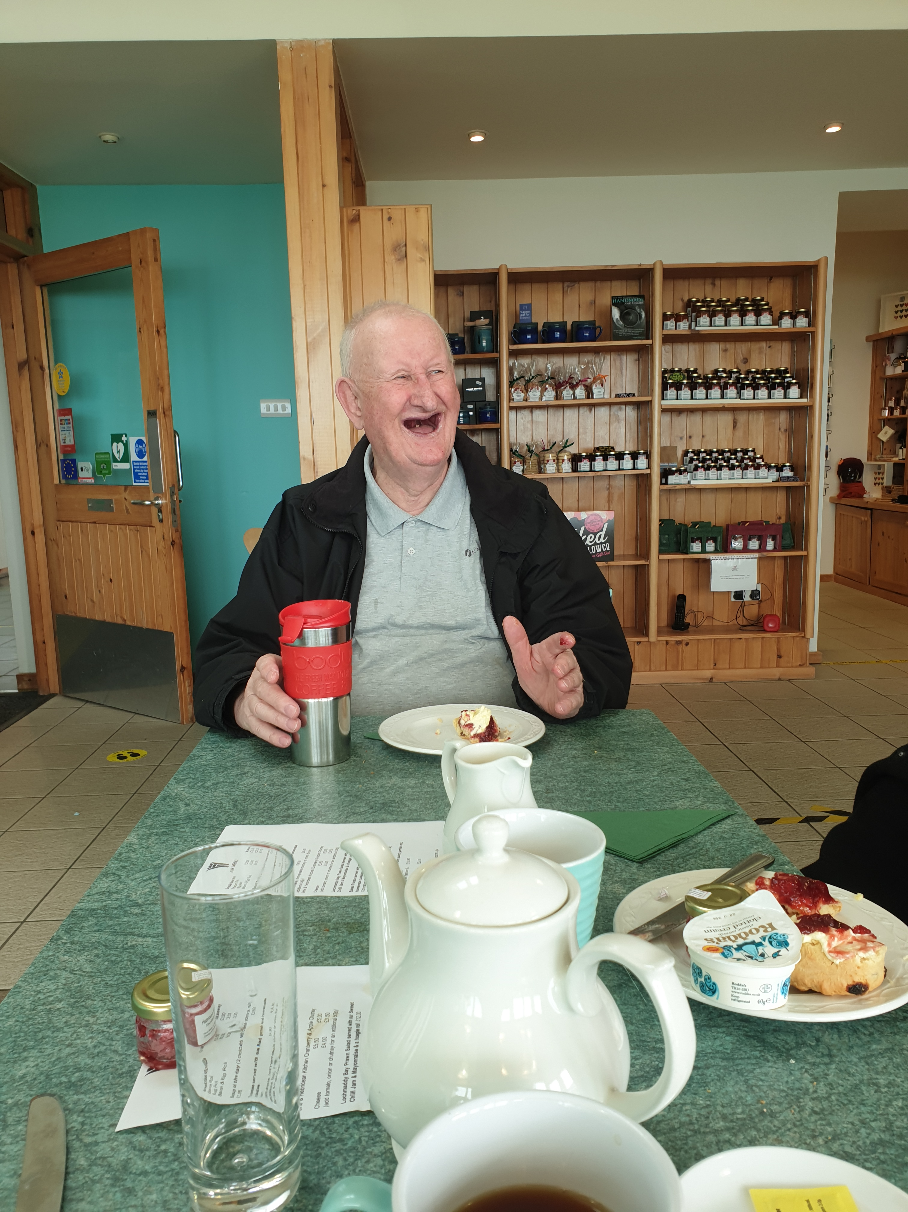
When respondents were asked about the impact that Caraidean Uibhist services have there was a wide range of responses, some going beyond reducing social isolation and loneliness, into the wider impact on families and friends, supporting with off-island appointments and signposting to other organisations.
As one service user commented, they have helped sort out my living accommodation while an external partner noted that we see a rapid decline in people health and wellbeing when the support is not there (from Caraidean Uibhist), they do the preventative work that is often unnoticed.
The organisations reach goes beyond social isolation and loneliness with examples of service users being helped to budget and manage their finances, helping apply and access grants for support and developing cooking skills and healthier lifestyles.
Some of the key impacts that went beyond reducing social isolation and loneliness included:

- Positive mental health and wellbeing
- Improved cognitive ability
- Improved physical fitness and physical wellbeing
- Creates opportunities for socialising and community spirit
- Rekindle connectedness with friends and the community
- Helping people apply for and get grants and support
- Helping people learn new skills
- Encourage independence and help people realise that they can do more things for themselves
- Involving service users in the events; they feel like they are giving back to their community

At the core of the service is the ability it has in making people feel connected to their community and to know that they do not have to be on their own or not able to do activities they want, as one staff member said if the person wants to walk on the beach to clear their head, then we will do that.
A common feature in the feedback was the blend and balance of the organisation being fun, friendly, and compassionate which was also very important to service users and their families; coupled with professionalism, organisation, and effectiveness.
I wouldn’t know where I would be if they didn’t have this
(Service User)

The key themes that emerged from stakeholder responses included:

Increased community connection: Communities and being connected to your local community for many people is critical not only for the essential services that they provide and offer but as a way to ensure you feel less remote, less isolated, and ultimately less lonely! In rural communities and those that have challenging geography and logistics having access to your community or even friends and family can be difficult; doubly so when factoring in the global pandemic. For many service users being connected to their community was vital, some stating that I am collected at home and taken to events which I would otherwise not get to …. I can get to visit the charity shop which I love but would not be able to do …. it means I can get out and mix with other people.
External stakeholders identified the value and benefit of community connectedness brought about through the befriending support, they enable the most isolated to interact and connect with their community and family …. (they) help service users feel part of a community or group of people which is so important for their mental health and wellbeing.
For Staff and volunteers helping service users maintain or indeed for some, helping service users to re-engage with their community, was an important function of their role, as one volunteer said we reach out to people and help them keep in touch with their community, similarly a staff member stated that the efforts toward building community and alleviating loneliness for people is important for their social and emotional wellbeing.
The ability to leave their home with the help of staff or volunteers and visit local areas and amenities as well as attend local events was very important and for many it enabled them to reconnect with friends and their community.
Health and Wellbeing: it is clear that the befriending service, from the feedback gathered, has a positive impact on the service users mental health and wellbeing. Indeed, local GPs and families make referrals direct to Caraidean Uibhist to support the person in these key areas. According to one staff member many of those they support suffered from a lack of contact during Covid-19 and had limited or restricted opportunities to engage in discussion and conversation which affects their cognitive ability, but our support provides that missed stimulation.
In the context of Covid-19 and the impact that it has had on those who were already vulnerable or socially isolated, having a befriending service has been a lifeline and an essential service! As one staff member described, as people have had a lack of opportunity to hold conversations they can lose their cognitive ability, but we help to stop this happening. Service users identified the benefits of accessing the service, describing it as an essential service …. I would be sad without it ….it makes me feel happy, and otherwise I would be at home fed up and lonely.
Takes pressure off the family and carers: knowing that their friend or family member is being supported by Caridean Uibhist enables those close to the person to do other activities or tasks that they otherwise would struggle to find the time to do. Service users were very open to this with some saying that they (Caridean Uibhist) take me out and about and take the pressure off my family and another that it helps me get out and away from my brother for a wee while and it means I will have things to talk to him about when I get home.
Reduced isolation and loneliness: providing the opportunity to meet people, whether remotely or in-person, throughout Covid-19 has been immensely important to the service users and their families and has managed to reduce the levels of social isolation and loneliness and improve wellbeing. Opportunities to create and develop new friendships as well as rekindle older ones was important to service users, staff, volunteers, trustees, and stakeholders. It became evident that having the opportunity to engage in activities whether that be remotely on ZOOM or in person were extremely important to all the service users responding. As one respondent noted I would be totally isolated if it wasn’t for the service and another service user sharing that I can get to visit the shops which I love and otherwise would not be able to do!
Meeting other people and having the opportunity to socially interact and continue existing relationships or indeed build new relationships was cited by many as an important feature of the service. This was evident in the feedback when respondents said they would be stuck at home fed up and lonely …. it has given me more mobility, increased my social life and relationships. The importance of the social interaction and its positive impact on the mental health and physical needs was summed up by one respondent who said it gets me up off my butt….I have 1,300 DVDs and there’s only so many times you can watch them!
no-one else can develop a deeper relationship with the person if the organisation wasn’t here
(staff member)

Tailored service: feedback suggests that the organisation is very responsive and quick to provide tailored support to those that are referred to their service; both the befriending and the drug and alcohol support services. Service users noted that staff and volunteers make them feel included and involved, as one service user stated they are always encouraging me, and I feel so welcomed. The feedback from external stakeholders also referenced the importance of a bespoke and person-centred service, with one stating that they (Caraidean Uibhist) offer a personalised service to some of the most vulnerable people which makes people feel loved and cared for.
Their impact can be measured broadly, in several ways with the most obvious being social inclusion, mental health and wellbeing, respite for families, keeping people active and respected (Strategic Partner)

Passionate and Caring Team: A Key feature that emerged from the feedback was the feeling that the staff and volunteers are dedicated and committed to helping reduce social isolation and loneliness through befriending. All respondents recognised that the organisation has a team of passionate and caring staff and volunteers who place the service user at the heart of their activity. As service users noted the staff and volunteers are fabulous….patient ….reassuring….and help me have a good time and I can’t praise them enough. Most of the service users referred to fun and enjoyment when engaging with staff and volunteers, and with the service as whole. It was evident that the service users felt comfortable and safe in the company of staff and volunteers and that the service they received was highly valued, with particular reference to the essential service it provided during Covid-19.
There was consensus that the staff and volunteers provided a high quality, bespoke and person-centred service while recognising that there were exceptional pressures placed on the service due to Covid-19 which made it more difficult to provide a seamless in-person service. It was also noted that Caraidean Uibhist work across many rural locations which not only impacts on access and logistics but has been further impacted by the increase in the cost of living and rising fuel costs.
Staff and volunteers have extensive knowledge of the local community and are able to help the service user to engage or indeed re-engage with their community. The latter was evident when discussing the service with a respondent who had returned to their community after many years away on the mainland. The knowledge and awareness of what exists at a local level is clearly an important feature of the organisation and helps provide a quick and efficient match between the service user and the befriender as well as inter agency working. As one staff member noted we link into other organisations and services such as TAGSA, Foodbanks, and the CAB which helps service users get a wraparound service and signposting.
In addition to the staff and volunteers, the Trustees play a very active role in supporting the work of the organisation, providing leadership and strategic steer when required. There are robust processes and protocols in place to ensure that the organisation adheres to regulatory requirements as well as checks and balances to ensure strong governance. The Trustees who all undertake an induction process before joining, meet on a monthly basis, and have a wide range of skills and experiences including business, human relations, finance and health and social care, as well as trustees with a lived experience.
Culturally Sensitive: Gaelic as a language has been in regular use in the Outer Hebrides since its arrival from Ireland in the 6th century, it has survived declines during periods when it was educationally unfashionable to use regional languages in preference to English and is now growing in popularity and is used by many Hebrideans as their first language. Caridean Uibhist as an organisation grounded within the fabric of the five island communities it serves ensures that is provides opportunities for Gaelic speakers to receive a service in their native tongue and that befriender and befriendee matches take cognisance of language needs.
3.3 Perception
As part of the exercise, stakeholders were asked about their perceptions of the organisation. The overwhelming response was positive with the organisation being highly regarded for the way it engaged service users, its person-centred approach, its compassion, friendly nature, and that it recognised the critical role that community plays in people’s lives.

When asked to describe the organisation service users chose the following:
- Fun
- Friendly
- Caring
- Supportive
- Patient
- Reassuring
- Exciting

When asked to describe the organisation external stakeholders chose the following:

- Person centred
- Warm
- Rooted
- Valued
- Supportive
- Community Focused
- Enabling
- Local service

When asked to describe the organisation staff, volunteers, and trustees chose the following:

- Community
- Professional
- Caring
- Essential
- Effective
- Supportive
- Friendly
- Fun
- Organised
- Proactive

All strategic partners were supportive of the work that Caraidean Uibhist carry out and see the organisation as key to supporting local communities reduce the impact of social isolation and loneliness, particularly following the impact of Covid-19. There was recognition of the work that they undertake and that the Manager has been integral in ensuring that the service is continually striving to meet the needs of the wider community while also ensuring that the organisation and its services are sustainable.
Referral organisations and funders identified the organisations’ ability to adapt, respond quickly and be forward thinking, particularly in their response to Covid-19 and ensuring that the service continued to deliver support to both existing and new service users.

It’s a lifeline service in many ways
(Trustee)

When asked to describe the organisation responses included:

Collaborative
Reassuring
Community

Patient
Functional
Wide Reaching
Forward Thinking
Essential
Caring

Enabling
Fun
Warm
Approachable

Organised
Fabulous
Concerned about the people
There for the People
Rooted
Professional

Friendly
Proactive
Local Service

Effective
Exciting
Supportive
Beneficial

3.4 Gaps and Opportunities
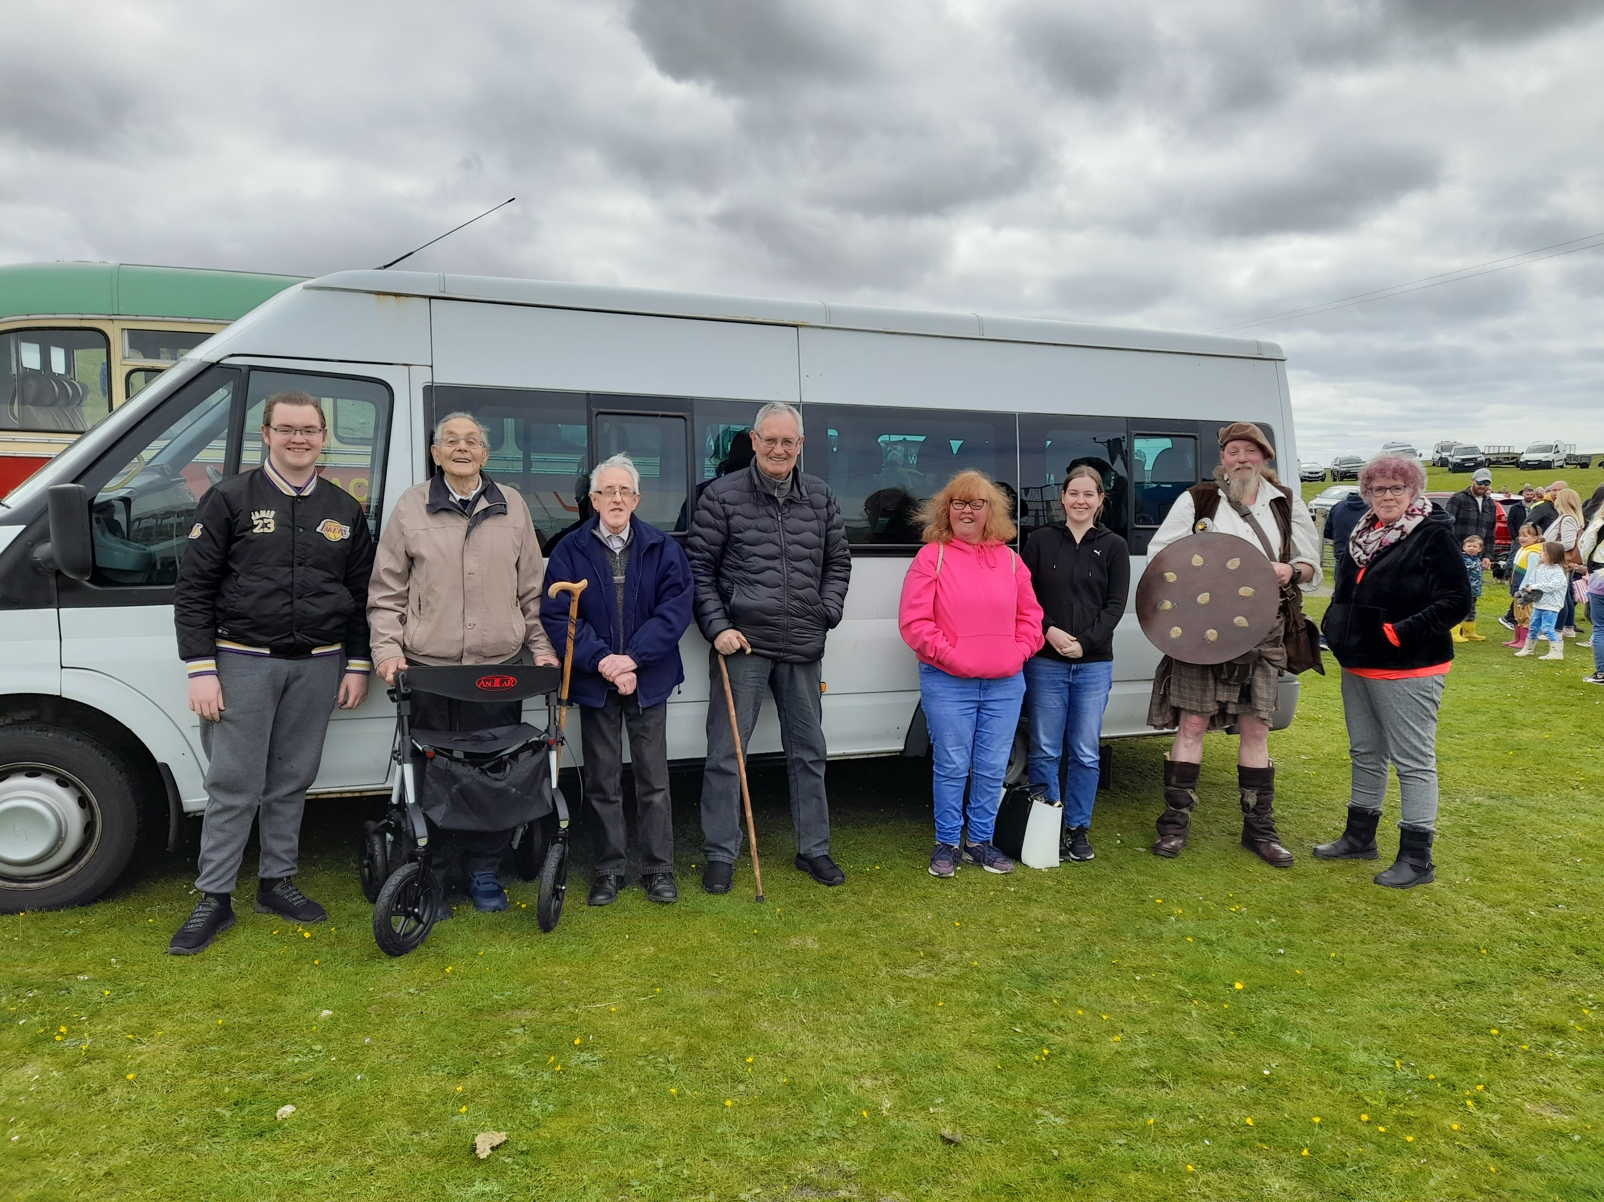
All those participating in the exercise were asked if they were any gaps in the current provision or opportunities to extend current services or introduce new ones. In the main respondents felt that the current provision met the needs of the service users and that Caraidean Uibhist should continue with what it does and continue to do it to a high standard. Caraidean Uibhist actively explores new opportunities to extend existing services or to meet emerging need and demand. However, like many organisations within the third sector they are faced with managing their services with limited funding and resource.
Where feedback did suggest additional support or new services it focused on:
- Increased number of social events: due to the success of the social events and community-based activity including on-line activity there were suggestions to introduce more events and themed social activities.
There was strong evidence that group work activities and a group work approach was very successful at engaging people and providing opportunities to develop relationships and build confidence. Service users overwhelming liked the group work activities and suggested that to have more would be very positive and well received.
- Intergenerational work: it was suggested that the current intergenerational activity, which is noted for its success, could be extended by linking further with the local schools. There was specific reference to more support for younger people who may also be experiencing loneliness and isolation, those who may have recently moved to the island, and young mums
- Partnerships: Caraidean Uibhist has successfully nurtured and developed a wide range of partnerships. It was suggested that this inclusive and collaborative model continues to grow, helping increase the number opportunities to work with other organisations and agencies in order to extend the wraparound support model i.e., TACSA, CAB, Foodbank. It was also suggested that more collaboration would help speed up the referral process and help identify those who need support quicker.
- Transport: logistics, geography and transportation were noted by a number of respondents as not only a challenge but as an opportunity to explore how best to ensure services users and the wider community can access services. There were a number of suggestions including securing funding for a wheel chair friendly mini-bus or more joined up use of existing community transport.
- Pilot Programmes: explore opportunities to create and roll out small scale Pilot Programmes or Initiatives which may also provide opportunities for trying and testing new approaches or delivery models, or collaborative work. In addition to seek out or secure additional service level agreements such as those already on place with the NHS.

If we can’t do it, then we will find someone who can
(External Stakeholder)

3.5 Spotlight Activity

Herb Garden Project
Due to the lockdown our “arts and crafts” themed activity was logistically impossible to facilitate; however, it was established that the majority of service users had access to cameras and could therefore record the “planting and growing” of a herb garden. Once again, this initiative was marketed through our social media, Gaelic radio, poster’s, and word of mouth. It gave 35 of our befriendees something they could do at home and even if they had limited mobility, they could still participate, being encouraged to plant, care and water the herbs. As the herbs grew it gave the service user further purpose and something to engage in discussion with their befriender
Having witnessed the impact the herb gardens had had on our community and as spring loomed, we felt that if we could give our service users something to venture outside of their house for, this would help with their anxiety and increase their mental well-being. In addition, by going out into their garden they could interact with neighbours which helped their mental health and cognitive stimulation. A further positive legacy is that we now have a competition on one of the islands with service users recording and sharing photos to see whose plants are growing the best.

Virtual Tea Party
We held a virtual tea party, bringing together the local community and families on the mainland. We arranged for a local supplier to make up tea party packs of cakes and refreshments and on the morning of the tea party these were distributed across our five island communities to 40 service users. The well-being and support generated during the event has evidenced how much the community gained by bringing people together. During the pandemic a number of local services and amenities ceased while opportunities to socially interact were limited. Feedback suggests that the cognitive stimulation for those taking part was increased particularly those who were shielding or isolating and gave those attending a chance to catch up with friends and find out what else was going on in the community It helped combat issues of isolation and encouraged those who had been nervous of doing so to be more adventurous in their use of digital technology.

4. Challenges
When exploring the challenges Caridean Uibhist currently face, and may in the future, there was a common theme from respondents focussing on funding, geography, transport, and the ongoing impact of Covid-19 on the service and the resulting increased need and demand. In addition, there was reference to the current cost of living crisis and how that is not only affecting individuals but also the organisational fuel costs for visiting service users, and associated utility bills.
I wouldn’t know where I would be if I didn’t have this
(Service User

When exploring further there were some clear internal and external challenges:
4.1 Internal
- Sustainable funding: the organisation is not alone when it comes to the need for attracting long-term sustainable funding, and in particular core funding. Organisations are faced with the challenge of budget squeezes coupled with reduced funding from grants and trusts which have diminishing funds while more applicants. For Caraidean Uibhist there is the added pressure of being a small team providing a service across five island communities while still needing to allocate time and resource to developing funding applications, bids, and tenders.
- Annualised Funding: The cycle of annualised and short-term funding impacts on the ability to plan resources and delivery, with funding often going beyond a one-year cycle; notwithstanding the resource required to ensure there is an exit strategy in place, funding applications developed and submitted, and that staff will stay for the duration of the contract given the level of uncertainty.
- Increased Need and demand: It is well documented that Covid-19 has had a massive impact on people’s mental health and wellbeing and the incidence of loneliness and social isolation has dramatically increased across many Scottish communities. The challenge for Caraidean Uibhist is to ensure that they have the adequate resource and capacity in order to meet the demand and that any stretch and challenge does not impact on existing services or the quality of the services. As one trustee noted there is in the main an ageing population within an ageing community which will naturally increase the need and demand for Caridean Uibhist services.
- Volunteers: volunteers, and volunteers that are appropriately trained are critical to the success of the service. Ensuring that there is an adequate number of volunteers is a common problem across many third sector organisations. Initially as Covid-19 impacted there was an increase in the number of volunteers as people were either working from home with more flexibility or were placed on furlough or wanted to support their community as they witnessed the immediate impact of Covid-19. However, as furlough ended and people were gradually going back to their workplaces the number of volunteers started to fall, coupled with an increase in demand. This scenario has placed increased strain on the service with a need to ensure that there is raised awareness of the organisation and the on-going need to recruit volunteers.
- Logistics: given that the organisation operates across 5 island communities with some service users in very remote locations, there are pressures placed on the service around logistics and transport, which have been made more acute with the increase in fuel costs. While Caraidean Uibhist ensures that service users are given the same high-quality support no matter their location or what logistical challenges it presents, it does impact on time and resources as well as operating costs when developing funding applications and tenders.
4.2 External
- Competition for Funding: feedback suggested that not only were there limitations on funding opportunities but also that local organisations would be in competition for the same funding! While this scenario is not unique to the Outer Hebrides it should be seen through the lens of a funding landscape that will see available funds reduce, increased funding based on targeted outcomes and outputs, and funders looking for greater joined up delivery and evidence of collaborative working.
- Cost of living crisis: the impact on the organisation of rising operational costs including utilities and rent as well as the fuel costs associated with staff and volunteers visiting service users or facilitating off-island transportation cannot be underestimated. The challenge for many organisations are to ensure that rising costs do not result in a reduction in current essential services or the ability to continue to meet service user needs.
- Collaboration: the organisation should continue to create opportunities for more collaborative work and working jointly on projects as well as funding opportunities. Feedback suggested that organisations do actively communicate and share information and intelligence, including meeting monthly, and that this should approach should continue to be actively promoted.
- Extending the reach: Caraidean Uibhist like other organisations supporting people and communities across the five islands wants to ensure that they support everybody. However, there is always the issue of making sure that the services actually extend to everyone and not just those who are already known to services or are themselves aware of what services are available. Working alongside partners to make sure they reach the hardest to reach and most disengaged and those that are the most isolated and remote geographically and logistically.

5. Conclusion
5.1 Conclusion
The engagement exercise has provided an opportunity to explore the impact Caraidean Uibhist has and explore feedback from a wide range of stakeholders, staff, and volunteers, as well as identifying opportunities to strengthen, develop and extend their current provision.
Overall, there is a high degree of satisfaction with the services provided and the organisational model and approach; with staff and volunteers recognised for compassion and empathy and a broad understanding of the island communities they operate in.
It is evident from the feedback that Caraidean Uibhist provide an essential service to individuals and their communities and that while there are challenges, there will continue to be a need for their tailored services.

Scottish Government, Scottish Household Survey, Published 2020 https://www.gov.scot/collections/scottish-household-survey-publications/
https://www.gov.scot/publications/connected-scotland-strategy-tackling-social-isolation loneliness-building-stronger-socialconnections/
A Summary of Recent Research Evidence About loneliness and social isolation, their health effects and the potential role of befriending, Mary Roberts, 2014, Befriending Networks
Age Scotland. Tackling Loneliness. Published 2015
A Stitch in Time in - The Benefits of Befriending - Befriending Network
Cattan M, Kime N, Bagnall A-M. The use of telephone befriending in low level support for socially isolated older people - an evaluation. Health & Social Care in the Community. 2010;19(2):198–206
Janine Wiles, Tessa Morgan, Tess Moeke-Maxwell, Stella Black, Hong-Jae Park, Ofa Dewes, Lisa Ann Williams & Merryn Gott (2019) Befriending Services for Culturally Diverse Older People, Journal of Gerontological Social Work, 62:7, 776-79
Evaluation of the British Red Cross Community Connectors Programme Final Report, Social Return on Investment: May 2019
Befriend a Child Social Impact Assessment - July 2017 – Deloitte https://socialvalueuk.org/wp-content/uploads/2017/09/Deloitte-Impact-Report.pdf
Walsall Council Making Connections Walsall Social Prescribing Service Summary Evaluation Report - January 2020
Harnessing the power of communities befriending in Bradford Research Study 2019 - Bradford VCS Alliance

